Początek formularza

Dół formularza

**18 Top-Rated Tourist Attractions in Madrid**

**avenues, buzzing, bustling,**

Full of energy and packed with cultural attractions, Madrid is a modern metropolis that offers a taste of the real Spain. Wide …avenues…………….are congested with traffic, but beautiful parks break up the urban sprawl.

Madrid is a hub of social life with a happening café culture and …bustling……………….nightlife. Constantly …buzzing………………… with activity, the city offers so much to see and do that you will be spoiled for choice.

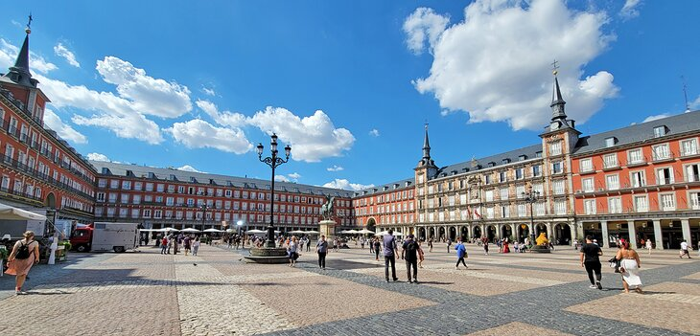

Plaza Mayor | Photo Copyright: Lana Law

**displays, savvy, cherished,**

The world-class Prado Museum …displays……………….. an endless array of masterpieces created during the Golden Age of Spain, and the 18th-century Royal Palace rivals the Château de Versailles in France.

Be sure to experience Madrid in the evening, when the city really comes to life. Madrileños love going out on the town, and the *paseo por la noche* (evening stroll) is a …cherished…………………. ritual.

If possible, it's best to avoid visiting during summer when the heat is oppressive. …savvy……………………. travelers come to Madrid during the springtime or autumn to take advantage of more mild weather.

Spain's capital city, Madrid boasts an impressive array of historical monuments and art museums, as well as pleasant gardens and public plazas. Learn more about the best places to visit with our list of the top attractions and things to do in Madrid.

**1. Museo Nacional del Prado**

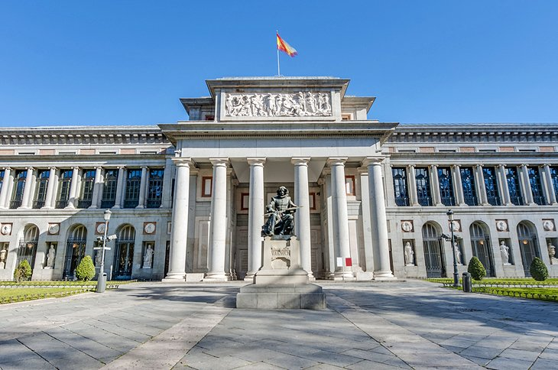

Prado Museum

**assortment, knowledgeable, depiction, daunting,**

A truly world-class museum, the Museo Nacional del Prado has a collection of more than 8,000 paintings and 700 sculptures. Among its extensive …assortment………………….of artworks are many masterpieces, including celebrated paintings that rival the most famous works of the Louvre Museum in Paris.

The [Prado Museum](https://www.museodelprado.es/en/) displays around 2,300 pieces of the collection in more than 100 rooms on three floors. Trying to see it all in one visit can be …daunting……………………., but it's possible to focus on a specific itinerary of masterpieces. The Prado suggests "routes" (self-guided tours) of specific works.

Spanish paintings from the 12th century to the early 19th century form the majority of the collection. The assortment of paintings by **Francisco de Goya** comprises a remarkable 140 works. Also not-to-be-missed is ***Las Meninas***, a …depiction………………..of the Spanish royal family of Felipe IV created by Velázquez in 1656.

Other must-see works in the Spanish Painting collection include *The Annunciation* by El Greco, *Jacob's Dream* by José de Ribera, *The Third of May* by Goya, *The Virgin and Child*by Luis de Morales, *Christ Embracing Saint Bernard* by Francisco Ribalta, and *The Immaculate Conception* by Murillo.

Part of the Prado Museum's exhibition space includes a contemporary building and the renovated 16th-century cloister of the San Jerónimo el Real monastery. These galleries display a noteworthy collection of 17th-century Spanish religious paintings.

Get the most out of your time at the Prado by joining a [Skip the Line: Prado Museum Tour in Madrid](https://www.viator.com/tours/Madrid/Skip-the-Line-Prado-Museum-Tour-in-Madrid/d566-2140PRADO?eap=planetware-tours-14254&aid=vba14254en), avoiding the long lines and going directly to the most interesting galleries. On the 90-minute tour, your …knowledgeable……………….guide provides an overview of the museum's must-see masterpieces, while providing historical context to help you understand the artworks.

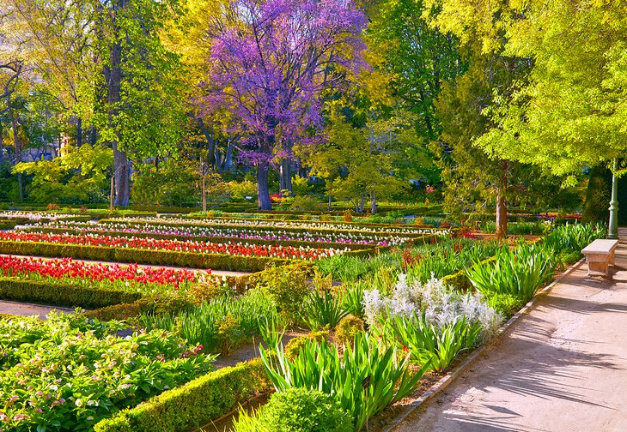

Real Jardín Botánico (Royal Botanical Garden)

**shady, sculptures, ambiance,**

After touring the art collection, tourists can relax at the **Real Jardín Botánico** (Royal Botanical Garden) located next to the Prado Museum. This lovely green space features …shady……………. pathways, benches, …sculptures……………….., greenhouses, a Kitchen Garden planted with vegetables, and a Rose Garden that blooms in May and early June. The Real Jardín Botánico is also home to the **Museum of Natural History**.

About a 10-minute walk from the Real Jardín Botánico is the popular [Restaurante TriCiclo](https://www.restaurantetriciclo.com/en) (28 Calle Santa María), which serves lunch and dinner in a contemporary-style dining room with a casual …ambiance…………….. The restaurant specializes in international cuisine, prepared from seasonal market ingredients with gastronomic flair.

Address: Paseo del Prado, Madrid

**2. Buen Retiro Park and the Crystal Palace**

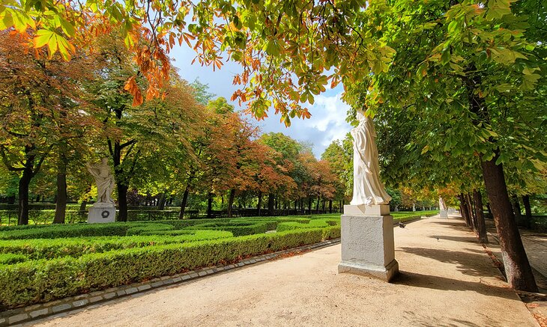

Retiro Park | Photo Copyright: Lana Law

**manicured, hustle and bustle, encompasses,**

The Buen Retiro Park (**Parque del Retiro**) is an oasis of peace in the heart of Madrid. This lush and beautifully …manicured……………… park offers an escape from the …hustle and bustle……………………of the city. The park …encompasses…………………….. more than 125 hectares and is shaded by over 15,000 trees.

Created for the Count-Duke of Olivares in the 17th century, the historic park has an elegant ambiance with its variety of gardens and tree-lined paths. The Parque del Retiro was owned by the Spanish royal family until the 19th century; since then it has been a public park.

From the main entrance at the Plaza de Independencia, visitors arrive at the pool in the center of the park. From here, paths lead to the enchanting La Rosaleda (**Rose Garden**), the formal French **Jardín de Don Cecilio**, and the Andalusian-style **Jardines de Cecilio Rodríguez**.

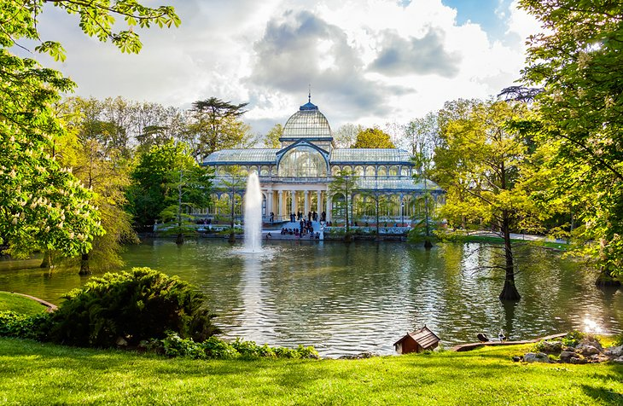The Crystal Palace at Buen Retiro Park

**splendid, scenic, tranquil,**

Built in 1887, the **Palacio de Cristal** (Crystal Palace) is a …splendid…………………cast-iron and glass pavilion that presents exhibitions of contemporary art. The Crystal Palace looks out onto a graceful fountain and reflecting pool. Visitors will find other interesting fountains at Buen Retiro Park including *Los Galápagos* (*The Turtles*), *El Ángel Caído* (*The Fallen Angel*), and *La Alcachofa* (*The Artichoke*).

Locals and tourists alike enjoy boating on the park's …tranquil…………….. lake. Other favorite things to do include taking the kids to puppet shows at the Teatro de Títeres, going for walks on the …scenic………………. tree-lined paths, and basking in the sun or relaxing in the shade at one of the park's outdoor cafés.

For stargazers, the park has an**observatory** that was built in 1790.

**3. Royal Palace and Gardens**

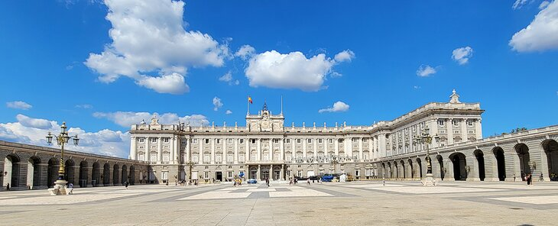Royal Palace, Madrid | Photo Copyright: Lana Law

**grandiose, adorned, balustrade, commissioned,**

This …grandiose……………………. palace is the Spanish version of Versailles, a royal court designed to impress. However, unlike Versailles, which is now just a museum, the Royal Palace of Madrid (Palacio Real de Madrid) is still the official residence of a monarch (the King of Spain) and continues to be used for official State events.

The palace was … commissioned …………………..by Philip V in the 18th century. The majestic Neoclassical facade is crafted entirely from granite and white Colmenar stone. The facade's Ionic columns and Doric pilasters are based on drawings that the sculptor Bernini originally intended for the Louvre in Paris. The …balustrade…………………features statues of Spanish kings.

The most striking aspect of the interior is the imposing staircase at the entrance hallway, with a fresco of *The Triumph of Religion and the Church*, that leads up to the main floor. Throughout the palace, masterpieces of art decorate the walls: paintings by Velázquez, Goya, Rubens, El Greco, and Caravaggio, and exquisite Flemish and French tapestries.

The **King Charles III apartments** are among the most beautiful rooms in the Royal Palace. These rooms are…adorned……………………. with refined decor of the Enlightenment era.

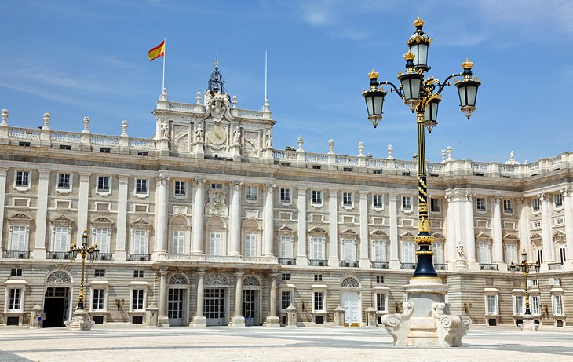Royal Palace and Gardens

**finest, sumptuous, delightful, buffs, tapestries,**

A masterpiece of Rococo style, the Salón del Trono (Throne Room) is adorned with frescoes by Tiepolo including *The Greatness of the Spanish Monarchy*, one of his…finest…………………… works. Still used for State ceremonies, the Throne Room is clad in …sumptuous………………….. red velvet and decorated with valuable …tapestries………………., mirrors, furniture, and chandeliers.

History …buffs…………………… will want to visit the palace's **Royal Armory** (La Real Armería), which contains 3,000 exhibits dating back to the Middle Ages. On display are the armor and weapons that have been used by Spain's kings over the centuries.

Visitors should save time to explore the **Jardines del Campo del Moro**. These …delightful…………………….. historic gardens were created during the reign of Philip II and are landscaped in a formal French style with fountains and avenues. The 20-hectare green space provides a haven of tranquility in the center of Madrid. It's a wonderful place for relaxation and scenic strolls.

Address: Calle Bailén, Madrid

Madrid Royal Palace Map (Historical)

**4. Wander through the Plaza Mayor**

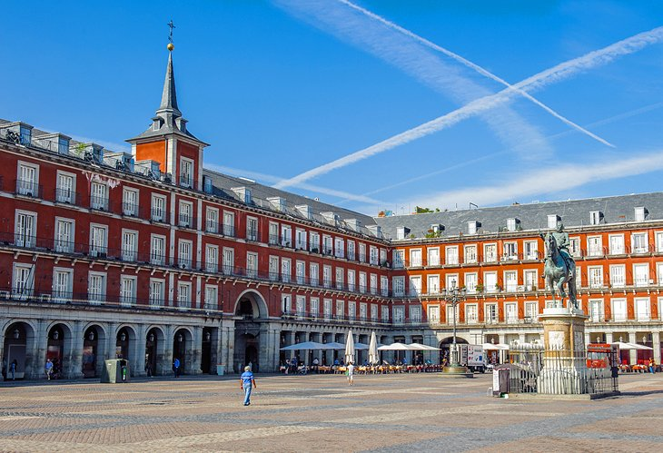Plaza Mayor

**reign, cobblestone, atmospheric, proclamation,**

This elegant 17th-century plaza was built during the ……………….. of Philip III and used as a center of commerce and municipal life, as well as the scene of ceremonial events such as the……………………. of a new king and the canonization of saints. The square also served as a venue for bullfights, dramatic performances, and knightly tournaments.

The Plaza Mayor took on its present appearance after a fire in 1790, when the corners were enclosed and the nine entrance arches were constructed, linking it to Calle de Toledo, Calle Mayor, Calle de Postas, and others.

Today, the Plaza Mayor continues to be an important gathering place in Madrid. The expansive ………………………square is a pedestrian area, surrounded by outdoor cafés and ………………………. restaurants shaded by its arcades. In the evenings, the square is a lively place to visit for both tourists and Madrileños.

A short walk from the Plaza Mayor is the [Chocolatería San Ginés](https://chocolateriasangines.com/) (5 Pasadizo San Ginés), famous for its *chocolate con churros* (hot chocolate with deep-fried pastries), which has been a specialty since 1894. This inviting chocolate boutique and café features marble tables and refined decor. No need to rush, the Chocolatería San Ginés is open 24 hours a day Wednesday through Sunday, and until 11:30 pm Monday and Tuesday.

**5. Puerta del Sol: The Heart of the City**

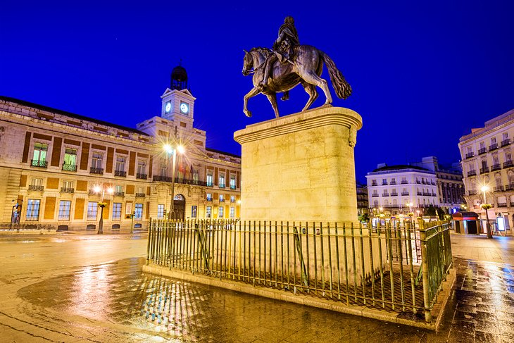Puerta del Sol: The Heart of the City

**emblem, aligns, spacious,**

The Puerta del Sol was named after the sun…aligns…………………. on the old city gate, which formerly stood here. This …spacious……………….. town square …emblem…………………… with the rising sun. Besides being a hub of public transportation (with several bus stops and Metro entrances), the Puerta del Sol is also the **"Kilometer Zero"**point from which all distances on the Spanish national road network are measured.

The Puerta del Sol has been the scene of many historic events, including the Spanish resistance to Napoleon on May 2nd, 1808, and in 1931, the Second Republic was proclaimed here.

Nowadays the square is a place to hang out and enjoy life. Lined with shops and cafés, the Puerta del Sol is still one of the most happening squares in Madrid.

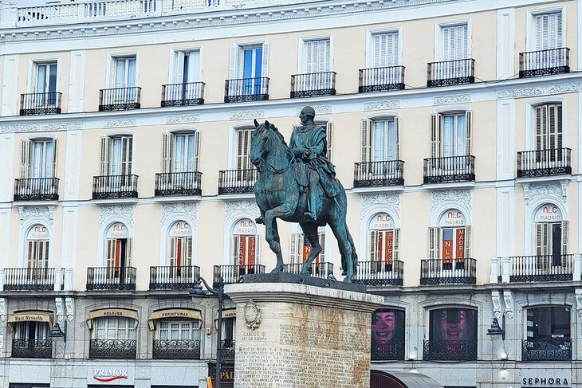Puerta del Sol | Photo Copyright: Lana Law

**packed, barricades, undergoing,**

The area around Puerta del Sol is …packed……………….. with restaurants and shops. For tourists seeking special gifts to bring back home, **La Violeta** (6 Plaza de Canalejas) is the place to go. The shop is just steps away from the Puerta del Sol. Founded in 1915, this family-run boutique offers the Madrid specialty of violet candies, as well as chocolate bonbons and other old-fashioned confections.

Note: Puerto del Sol is …undergoing…………………. major construction in 2023, and …barricades…………………….. and scaffolding dominate the scene.

**7. Estadio Santiago Bernabéu: Real Madrid's Stadium**

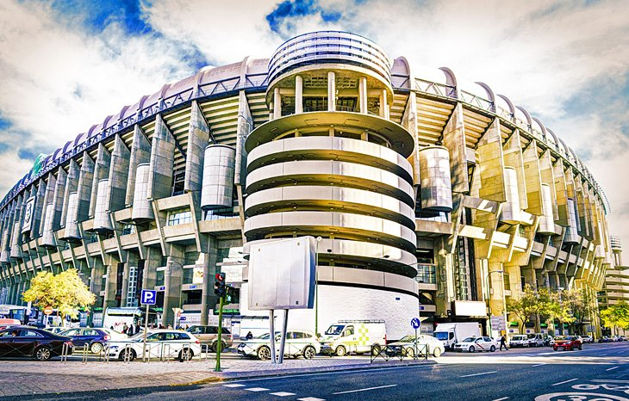Estadio Santiago Bernabéu: Real Madrid's Stadium

**draws, boasts, exhibits, retractable**

Not all of Madrid's tourist attractions revolve around art. One of its most-visited museums …draws……………… football (soccer) fans to the stadium known as [Estadio Santiago Bernabéu](https://www.realmadrid.com/), the home of the Real Madrid soccer club. The club …boasts…………………. unapologetically that their stadium is the "Greatest Stadium in the World."

You can take a tour of the stadium, as well as the museum, which displays trophies, team artifacts, and temporary …exhibits…………….. Tours also give fans a chance to enjoy the view of the field from the top of the stadium.

Significant infrastructure improvements are planned over the next few years for the stadium. They include a …retractable…………………. roof, digitization of the display screens, along with an underground car park.

**8. Museo Nacional Centro de Arte Reina Sofía**

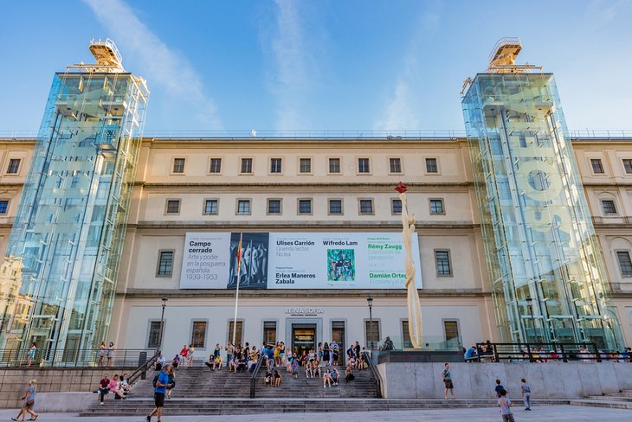Museo Nacional Centro de Arte Reina Sofía | Takashi Images / Shutterstock.com

**recall, displayed, imaginative, charming,**

Opened by Queen Sofía in 1986, the [Museo Nacional Centro de Arte Reina Sofía](http://www.museoreinasofia.es/en) is Madrid's avant-garde center for contemporary art. The sleek modern building was created by the architect Antonio Fernández Alba and has features that …recall…………………. the Pompidou Center in Paris, especially the three glass towers that house the elevators on the outside of the building.

Another wonderful surprise to visitors is the …charming……………garden in the inner courtyard filled with …imatinative…………….. sculptures.

The Museo Reina Sofía contains over 23,000 artworks in its collections. In its thorough representation of Spanish modern and contemporary art, the collection includes remarkable masterpieces such as works by Joan Miró, Pablo Picasso, Salvador Dalí, and Alexander Calder. The artworks are …displayed……………….in various rooms spread out in a vast exhibition space of 39,000 square meters.

Visitor amenities include a bookstore, **gift shop**, and audioguides. The museum also has a trendy café-restaurant, NuBel, which is open for brunch, lunch, afternoon refreshments, tapas, and dinner. Evening meals feature a lively ambience, with DJ music sets every night.

Address: 52 Calle de Santa Isabel, Madrid

**9. Fuente de Cibeles and Gran Via**

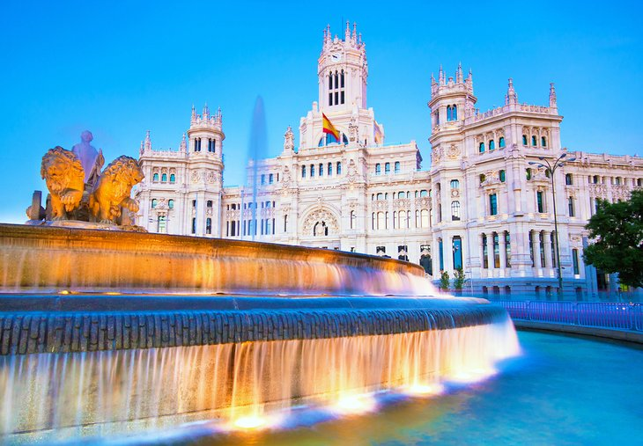

Fuente de Cibeles (Cybele's Fountain) in front of the Palacio de Cibeles

**emblematic, bustling, panoramic, chariot,**

Standing in a major traffic intersection, the Fuente de Cibeles (Cybele's Fountain) is one of the most …emblematic………………..monuments in Madrid. Lifelike statues depict the Roman Goddess Cybele riding a lion-drawn …chariot…………….. The fountain was created in 1782 by Francisco Gutiérrez and Roberto Michel with the original purpose of providing water for public use.

Behind the fountain is the **Palacio de Cibeles**, which houses the CentroCentro cultural center, which hosts art exhibitions and workshops, conferences, and concerts. The Centro Palacio de Cibeles has the [Restaurante Palacio de Cibeles](https://palaciodecibeles.com/restaurante-palacio-de-cibeles/) on the sixth floor, an elegant dining establishment with spectacular city views. Visitors can also admire …panoramic…………………vistas from the **Mirador observation deck** on the building's eighth floor.

Nearby (via Calle de Alcala) is one of Madrid's most popular shopping streets, the **Gran Vía**. Tourists will find many restaurants, hotels, and theaters on this …bustling…………………street.

Just off the Gran Vía on Calle de Jovellanos, the famous **Teatro de la Zarzuela** presents ballet performances and classical music concerts, including renowned performances of *zarzuela*- a unique type of satirical opera with songs accompanied by classical Spanish guitar music.

Address: Plaza de Cibeles, Madrid

**10. Mercado de San Miguel**

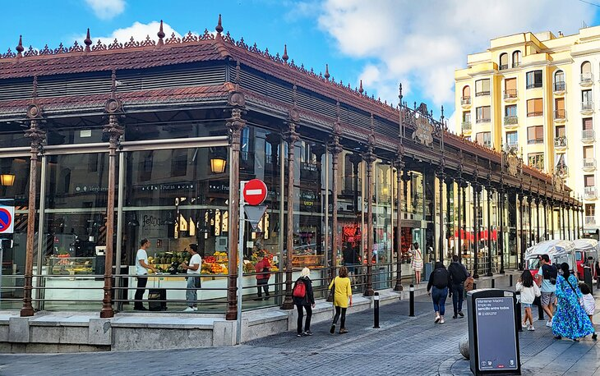

Mercado de San Miguel | Photo Copyright: Michael Law

**piled, soak up, tempting,**

Touring a city like Madrid with all its sights can bring on a fierce hunger. Fortunately, the [Mercado de San Miguel](https://mercadodesanmiguel.es/en/) has everything you need to recharge your natural batteries. Here, you'll find over 20 different vendors selling the freshest meats, cheeses, fruit, and tempting tapas.

Vendor stalls are …piled……………….. high with taste-bud …tempting……………. items. Figuring out what to eat may be the toughest task you face all day. Pick a few things from each place and then sit at one of the tables and …soak up…………………. the lively atmosphere.

The Mercado de San Miguel has been operating in the same location for over 100 years. You'll find it just to the west of Plaza Mayor.

Address: Plaza de San Miguel, Madrid

**11. Temple of Debod: An Ancient Egyptian Temple**

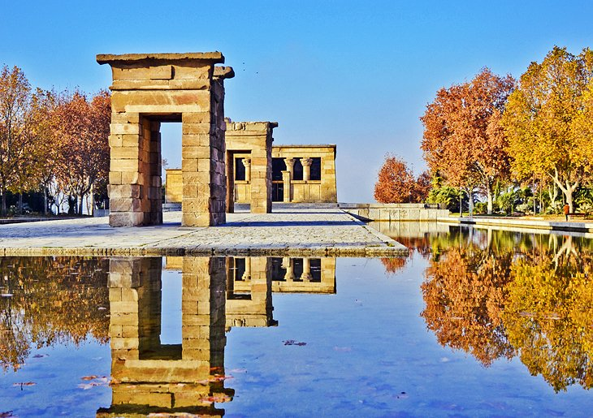

Temple of Debod: An Ancient Egyptian Temple

An ancient Egyptian temple in Madrid? Yes, such a thing does exist, and it can be found in La Montaña Park (close to the Plaza de España). A gift from Egypt, in thanks for Spain's help in saving the Abu Simbel temples during the building of the Aswan Dam, the Temple of Debod was brought to Madrid in 1968.

The temple was built for King Adikhalamani in the 2nd century BC and was dedicated to the Egyptian God and Goddess, Amun and Isis. Well-preserved original decorations are found inside the temple, which is rare for an archaeological site.

Originally the peaceful gardens surrounding the monument had reflective pools and a fountain; however, these features are no longer operating. Admission to the temple is limited, and the line moves very slowly. Sights inside are fairly limited, so if you see a long line, give it a pass.

Address: Parque de la Montaña, Calle de Ferraz, Madrid